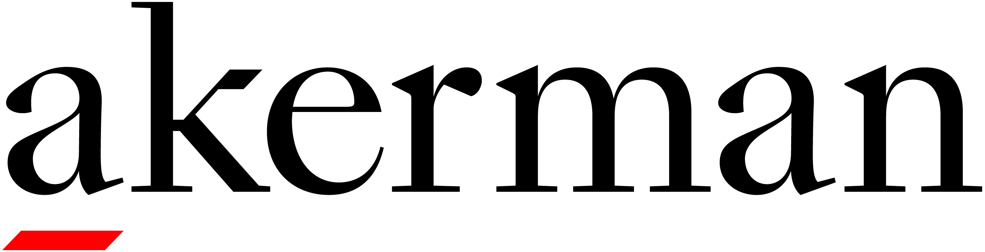
Seminar Evaluation
Please return to Barbara Maniscalco (barbara.maniscalco@akerman.com)

Title of Activity: New Federal Enforcement and Corporate Compliance - Identifying and Managing the Risk
Name of Presenter(s): Jackie Arango, Sergio Acosta, Ruben Castillo
Date of Seminar: February 3, 2021
Name of Participant First Name Last Name
(Optional):

1. On a scale of 1 to 5 how would you rate the quality of the content of today’s program?

(Poor) 1 2 3 4 5 (Excellent)

2. On a scale of 1 to 5 how would you rate the quality of the written materials?

(Poor) 1 2 3 4 5 (Excellent)

3. On a scale of 1 to 5 how would you rate the quality of the technology used to broadcast this program?

(Poor) 1 2 3 4 5 (Excellent)

4. What did you like most about this presentation?

__________________________________________________________________

__________________________________________________________________

__________________________________________________________________

5. What would you change about the presentation and/or what would you like to hear more about?

__________________________________________________________________

__________________________________________________________________

__________________________________________________________________

6. What was the main concept or piece of knowledge that you took away from this program?

__________________________________________________________________

__________________________________________________________________

__________________________________________________________________

Please rate the faculty on the same scale (1 being the lowest and 5 being the highest).

Instructor(s) Name(s): Jackie Arango

Knowledgeable: 1 2 3 4 5

Well-prepared: 1 2 3 4 5

Effective Communicator 1 2 3 4 5

Additional Comments: _____________________________________________________

________________________________________________________________________

Instructor(s) Name(s): Sergio Acosta

Knowledgeable: 1 2 3 4 5

Well-prepared: 1 2 3 4 5

Effective Communicator 1 2 3 4 5

Additional Comments: _____________________________________________________

________________________________________________________________________

Instructor(s) Name(s): Ruben Castillo

Knowledgeable: 1 2 3 4 5

Well-prepared: 1 2 3 4 5

Effective Communicator 1 2 3 4 5

Additional Comments: _____________________________________________________

________________________________________________________________________

